Design Patterns Research
Under the Esteemed Guidance of
Prof Dinesha. K. V.

IIITBangalore
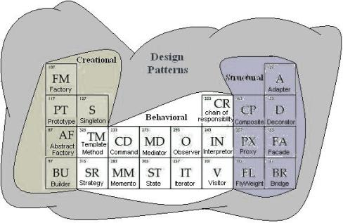
By,
Venkata Thippanna Rao. P. R. 2005145
Shahid Kamal 2005115
Supported By,
Rajendra Reddy. N. (Infosys)
Ravi Kumar. T. N. (i2 Technologies)

CONTENTS

- Preface:
- Acknowledgement:
  - My Supporters
  - My Team
- Introduction:
  - Why Design Patterns?
  - What are OOPs Principles?
  - Are these OOPs Principles sufficient?
  - Why is Polymorphism that important and how is that related to Composition?
  - Exploring the differences between Abstract Classes and Interfaces both meant by the term “INTERFACE” in Patterns language!
  - Classics and Classification?
  - Format and Vocabulary Followed!
- Patterns Classified for Ease of Understanding: As per GOF Standard
    - Creational Patterns FABPS
      - Factory Pattern
      - Abstract Factory Pattern
      - Builder Pattern
      - Prototype Pattern
      - Singleton Pattern
    - Structural Patterns ABCDFFP
      - Adapter Pattern
      - Bridge Pattern
      - Composite Pattern
      - Decorator Pattern
      - Façade Pattern
      - Fly Weight Pattern
      - Proxy Pattern
    - Behavioral Patterns CCIIMMTOSSV
      - Chain of Responsibility Pattern
      - Command Pattern
      - Iterator Pattern
      - Interpreter Pattern
      - Mediator Pattern
      - Memento Pattern
      - Template Pattern
      - Observer Pattern
      - Strategy Pattern
      - State Pattern
      - Visitor Pattern
- Issues related to Patterns: Worth a Discussion and Debatable Topics…
- Research Topic:
Problem Statement
Milestones
- Study details of and/or abstract of
“Integration Ready Architecture and Design”
By Jeff Zhuk
- References

